Portal Guideline
Version 1.2

28.5.2020

Change history

Versio | Pvm | Muutos
0.1 | 1.7.2019 | Registration
0.2 | 1.10.2019 | Capacity booking
0.3 | 2.10.2019 | API-interface and Swagger documentation published in test environment called staging. Technical info 7.10.2019  https://stg.gasgridportal.fi
0.4 | 15.11.2019 | Personal API access key in test staging environment
0.5 | 24.11.2019 | Production Portal https://gasgridportal.fi environment updated
1.0 | 17.12.2019 | An update for the Portal Guideline
1.1. | 27.12.2019 | Adjustments to the Guideline
1.2. | 28.5.2020 | New features and changes:  Straight below at the begin of guideline are new features which will be published
1.3 | 16.9.2020 | Coming soon description regarding new features like emission trade,

Notice
It is recommended users of Gasgrid Portal to clear your browser cache because it:
- Prevents you to use old forms
- Helps application run better

New updates has been reported in the portal front page à Latest information from the TSO : Announcements.
When TSO updates application Your browser may still use old files. If you don’t clear your cache, You may see old forms. Old files can cause display or access problems when you apply online.

New published features which are in use or will be

Network state symbol in portal
TSO will monitor closely system balance and if imbalance is not decreased with actions by market participants the forecast imbalance for the Gas Day is set yellow zone.
Symbol of system state and direction can be seen in portal in the right up corner.
- Sign plus indicates that system is long meaning that estimated offtakes are lower than intakes and
- Sign minus indicates that system is short meaning estimated offtakes are higher than intakes.
Moving mouse over the symbol display description and time.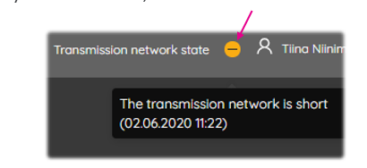

Nomination view
Shipper and Trader has nomination view for summary per gas days and list of each nomination.
- Nomination summary of each gas day
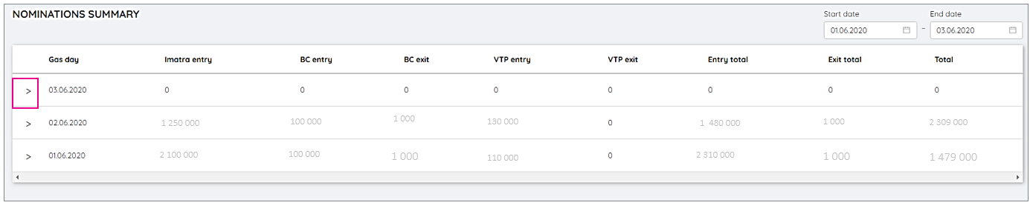
- Drill down symbol to list of latest nomination of gas day (point + direction + counterparty). Opened by clicking symbol >
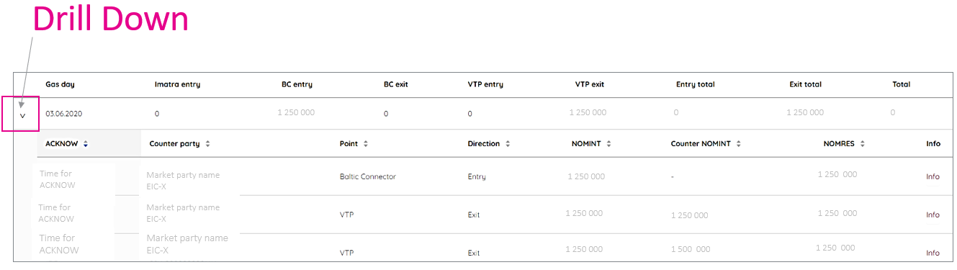
- Nomination intention information can be open by clicking the info
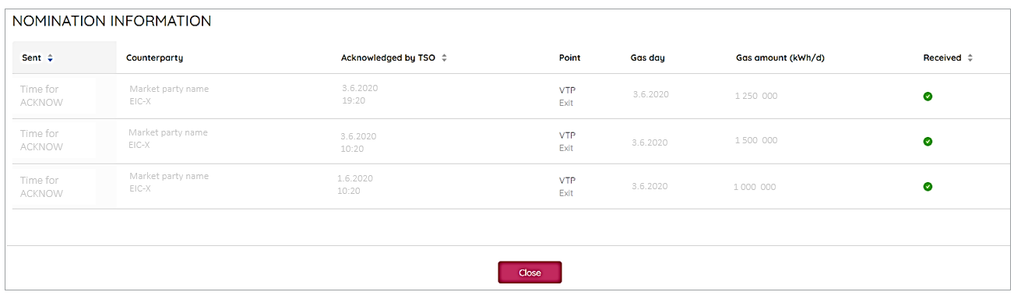

- Re-Nominations can be done by clicking the nomination row in drill downed nomination view.
Below is an example of shipper’s re-nomination form at 20:32. In this case Shipper has not nominated earlier and that’s why values are zero.
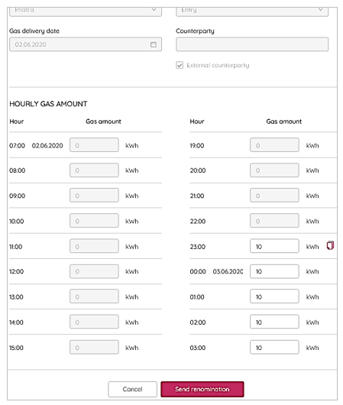

Notice: Nomination view does not have VTP counterparty's nominated amount of gas if those has not done in Portal. There will be improvements in Counterparty value regarding Baltic Connector and edigas messages which has sent via AS4 . This moment those values are not visible.
Search parameter will be added more during next weeks.

Shipper allocation per retailer (will be published 8.6.)
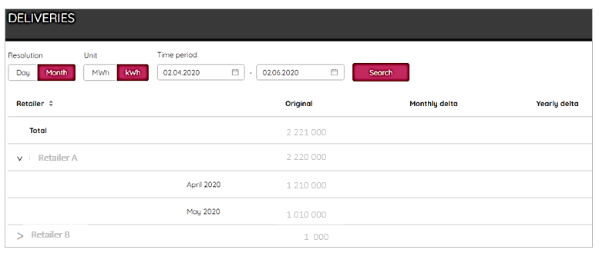
- First cycle of correction is monthly delta.
- Second cycle of correction is yearly delta.
Estimated Shipper allocation to the Retail Market
During gas day is updated estimation after every second hour to the my balance view. Calculated estimation is based on measurements of City Gate and Shippers earlier allocation. Shipper can fetch estimation from gas datahub api interface: 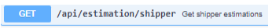
Edigas communication messages via AS4
Edigas nomination messages will be visible in Portal nomination view.
Invoicing data (implementation during June and August 2020)
- Imbalance responsible - Imbalance per das day (negative and positive)
- Shipper - Capacity product (long and short)
- Shipper - Capacity overrun
- Shipper - Commodity fee
- Shipper - Underutilization fee (BalticConnector)
- Transmission End User and Distribution System Operator
  - Energy tax
  - CO2 tax
  - Strategic Stock Pie
First and Second cycle Correction data (implementation during June and August 2020)
Emissions trading data (implementation during June 2020)
- Lower heat Value and
- Emission Heat Factor
Contents
Change history 2
1 Introduction 5
1.1 Overview Systems in Finnish Commercial Gas Market 5
2 Before starting to use the Portal 6
3 User access rights 7
3.1 Create new user 7
3.2 Generate API interface access 8
3.2.1 Key for yourself 8
3.2.2 Using Portal API with access key 10
4 Market parties and delivery relationships 10
4.1 Information about delivery relationships to be submitted to the Portal 13
4.2 Delivery relationship to Shipper 13
4.2.1 Biogas Injecting party 14
4.2.2 Retailer and retailer with delivery obligation 14
4.2.3 Distribution System Operator 14
4.2.4 End User in transmission network 15
4.3 Metering site 15
4.3.1 Metering information API end points 16
4.4 Fetch market parties for currently logged in user (API) 17
4.5 Fetch market party data (API) 17
5 Balance Group 18
5.1 Rules for Balancing Responsible Parties and members of the Balancing Group 18
5.2 Notify to be Balance Responsible Party 19
5.3 Notify to be a member of Balancing Group 20
6 Capacity (relevant for shippers) 21
6.1 Capacity Booking 21
6.1.1 Booking process 22
6.1.2 Capacity information shippers receive from the Portal 23
6.2 Transferring of capacity rights 24
6.3 Overrun in Exit Zone and Biogas 25
6.4 Available Capacity (firm and interruptible) 26
7 Energy 26
7.1 Trade Notification 26
7.2 Nomination at Balticconnector 28
7.3 Nomination at Imatra 30
7.4 Confirmed Nominations 30
7.5 Nomination (API) 30
8 Balance information 31
8.1 Data provided for Balance Responsible Parties by TSO 32
8.2 Balance Responsible’s data 33
8.3 Each Shipper’s or Trader’s balance 33
8.4 Balance (API) 34
8.5 Forecast of System Imbalance in yellow zone 34

Introduction
Portal has been developed based on the gas market rules. English version of the rules are published in gasgrid.fi, and this document describes main-functionalities which has been deployed in the Portal.

Overview Systems in Finnish Commercial Gas Market

There are two main systems in Finnish gas market for customers:
- Gasgrid Portal for wholesale market
- Gas Datahub for retail market (called also “KaTSO”)

Protocol AS4 is available in nomination process. Edig@s messages NOMINT, ACKNOW, NOMRES are used. These are options for Shippers and Traders.
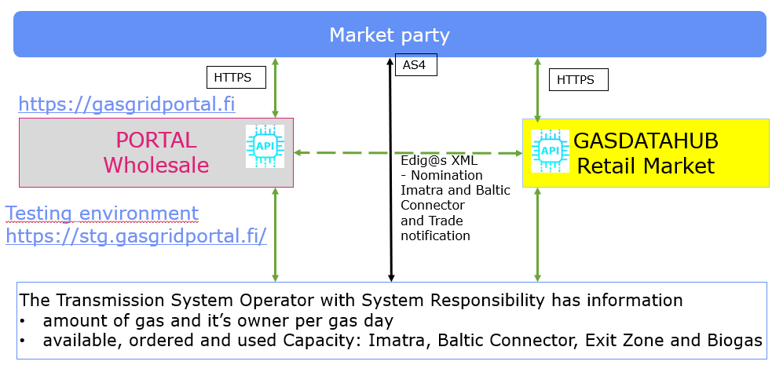
Content of Portal:
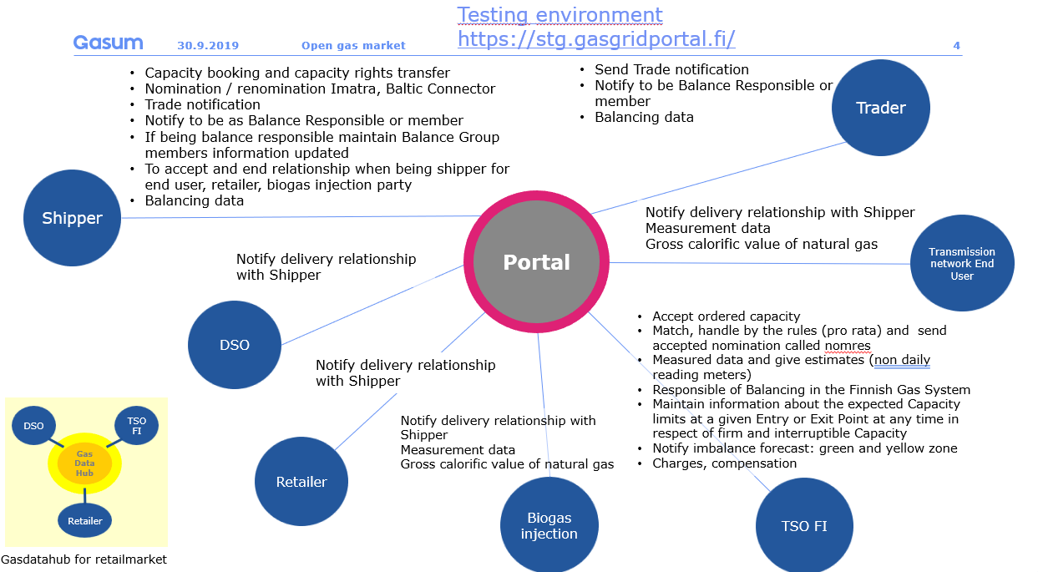

Before starting to use the Portal
A new participant requesting market participant registration shall submit its master data to the TSO using the registration form available on the TSO’s website. When submitting its master data for the first time to the Register of Market Participants, shipper, trader, biogas injecting party, retailer or transmission network end user shall submit the data no later than thirteen (13) business days before the first gas day on which the master data are to take effect.
After a participant has registered its data for the first time in the Register of Market Participants, sent its valid extract from the Trade Register (or a corresponding foreign document if the enterprise is registered outside Finland) as well as its latest financial statements (if available) to the TSO, and entered into a participant framework agreement with the TSO, data updates in the Register of Market Participants may take place on the Portal.
All registered market participants shall be obliged to keep their master data up to date. Updates of master data shall be made on the Portal no later than three (3) Gas Days before they are to take effect in the Register of Market Participants.
You can find your master data as follows:
- Click “Market Parties”
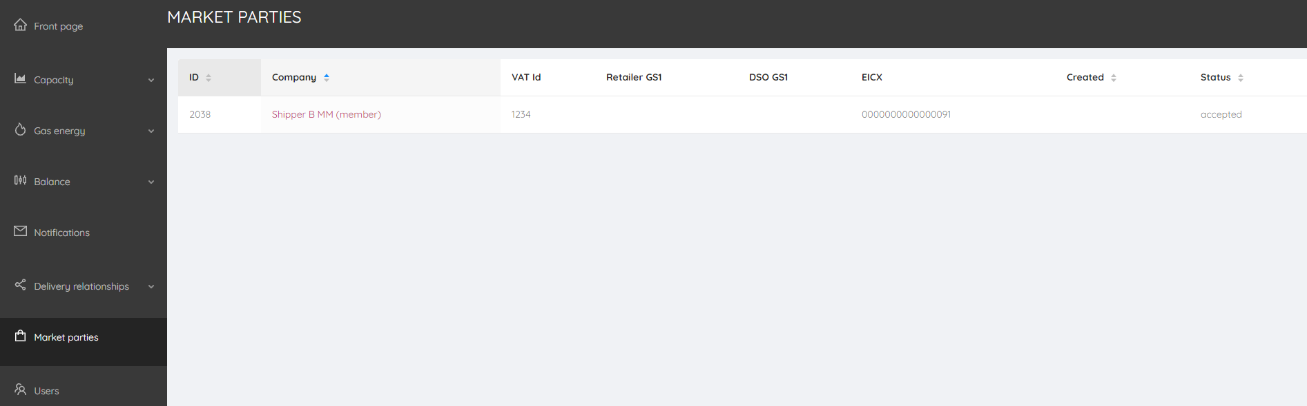
- Click the company you are presenting. In this example it is “Shipper B MM”.
- The following information window is opened:
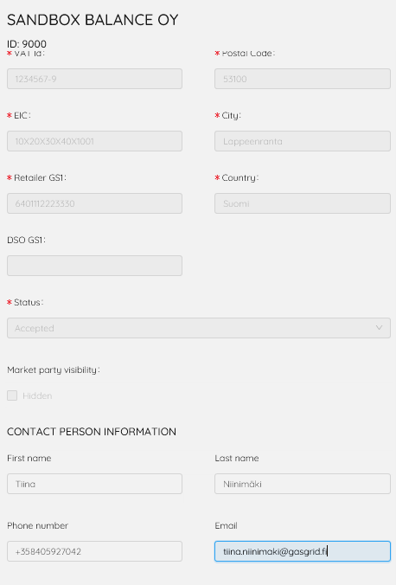
If you need to make some changes to your data, please contact TSO (commercial@gasgrid.fi).

User access rights

Create new user
You can add new users to use your account as follows. If you don’t have “Users” box in the bottom left corner, you don’t have “Admin” rights.
- Click “Users”
- “Add new user”
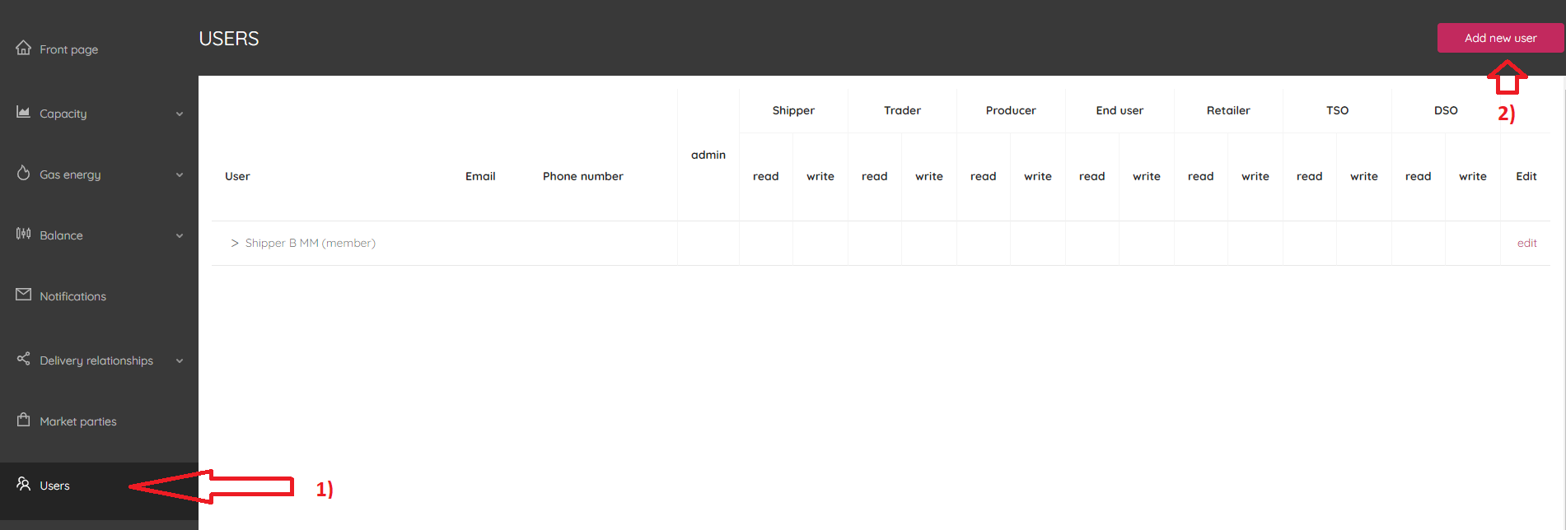

- The following window opens:
- Fill the requested information. You can set the permissions for the new user ticking the box(es). Please note that the phone number must include the country code (e.g. +358 45 123 4567).

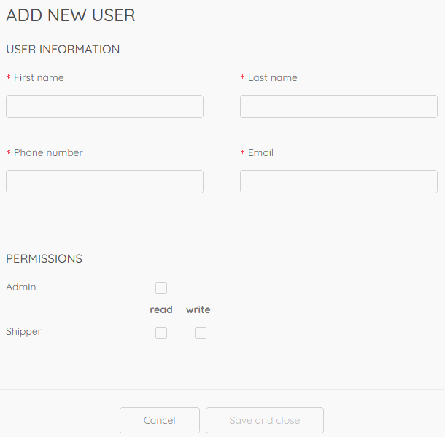
- Set the permission levels
- ADMIN: Ticking box “Admin” means that the new user has possibility to make changes to the user rights functionalities. You can also add new users to your account or remove the users. Note! If you click “Admin” box only, not “Read” or “Write” boxes, you will not have permission to submit nominations or book capacity, or see these windows.
- READ: Ticking box “read”, you give access to read the data belonging to your role.
- WRITE: Ticking box “write” you give permission to add data and perform actions in your market role.

Note: In the screenshot above this example is demonstrated with the role of shipper. If you have the role of end user of transmission system, “Shipper” would be replaced with “End User”.
If you have several market roles or companies under the same username and password, you will see them listed
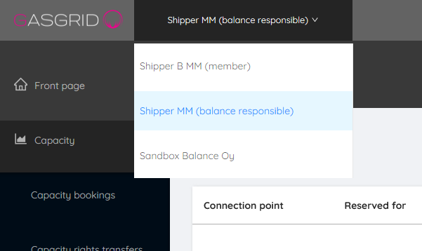
If you already have Portal access with one e-mail, you will get notification if someone has added you as a user for market participant. This means you have access to several accounts with the same e-mail and your personal password you have set for your e-mail. The list can be seen as above.
If someone adds you as a user for his account and you don’t have e-mail added to the Portal before, you will receive e-mail that you have been added as a user for market participant X. Also, a temporary password is in the e-mail. When you have registered to the Portal first time, you can change your temporary password.

Generate API interface access
Please check out the instructions for using API here: https://gasgridportal.fi/apidocs. Authentication is needed to access API Docs in the Portal.

Key for yourself
Endpoint: POST /users/self/accesskeys
Click “Try it out” and then “Execute” buttons in API Docs or call endpoint directly with e.g. Postman.

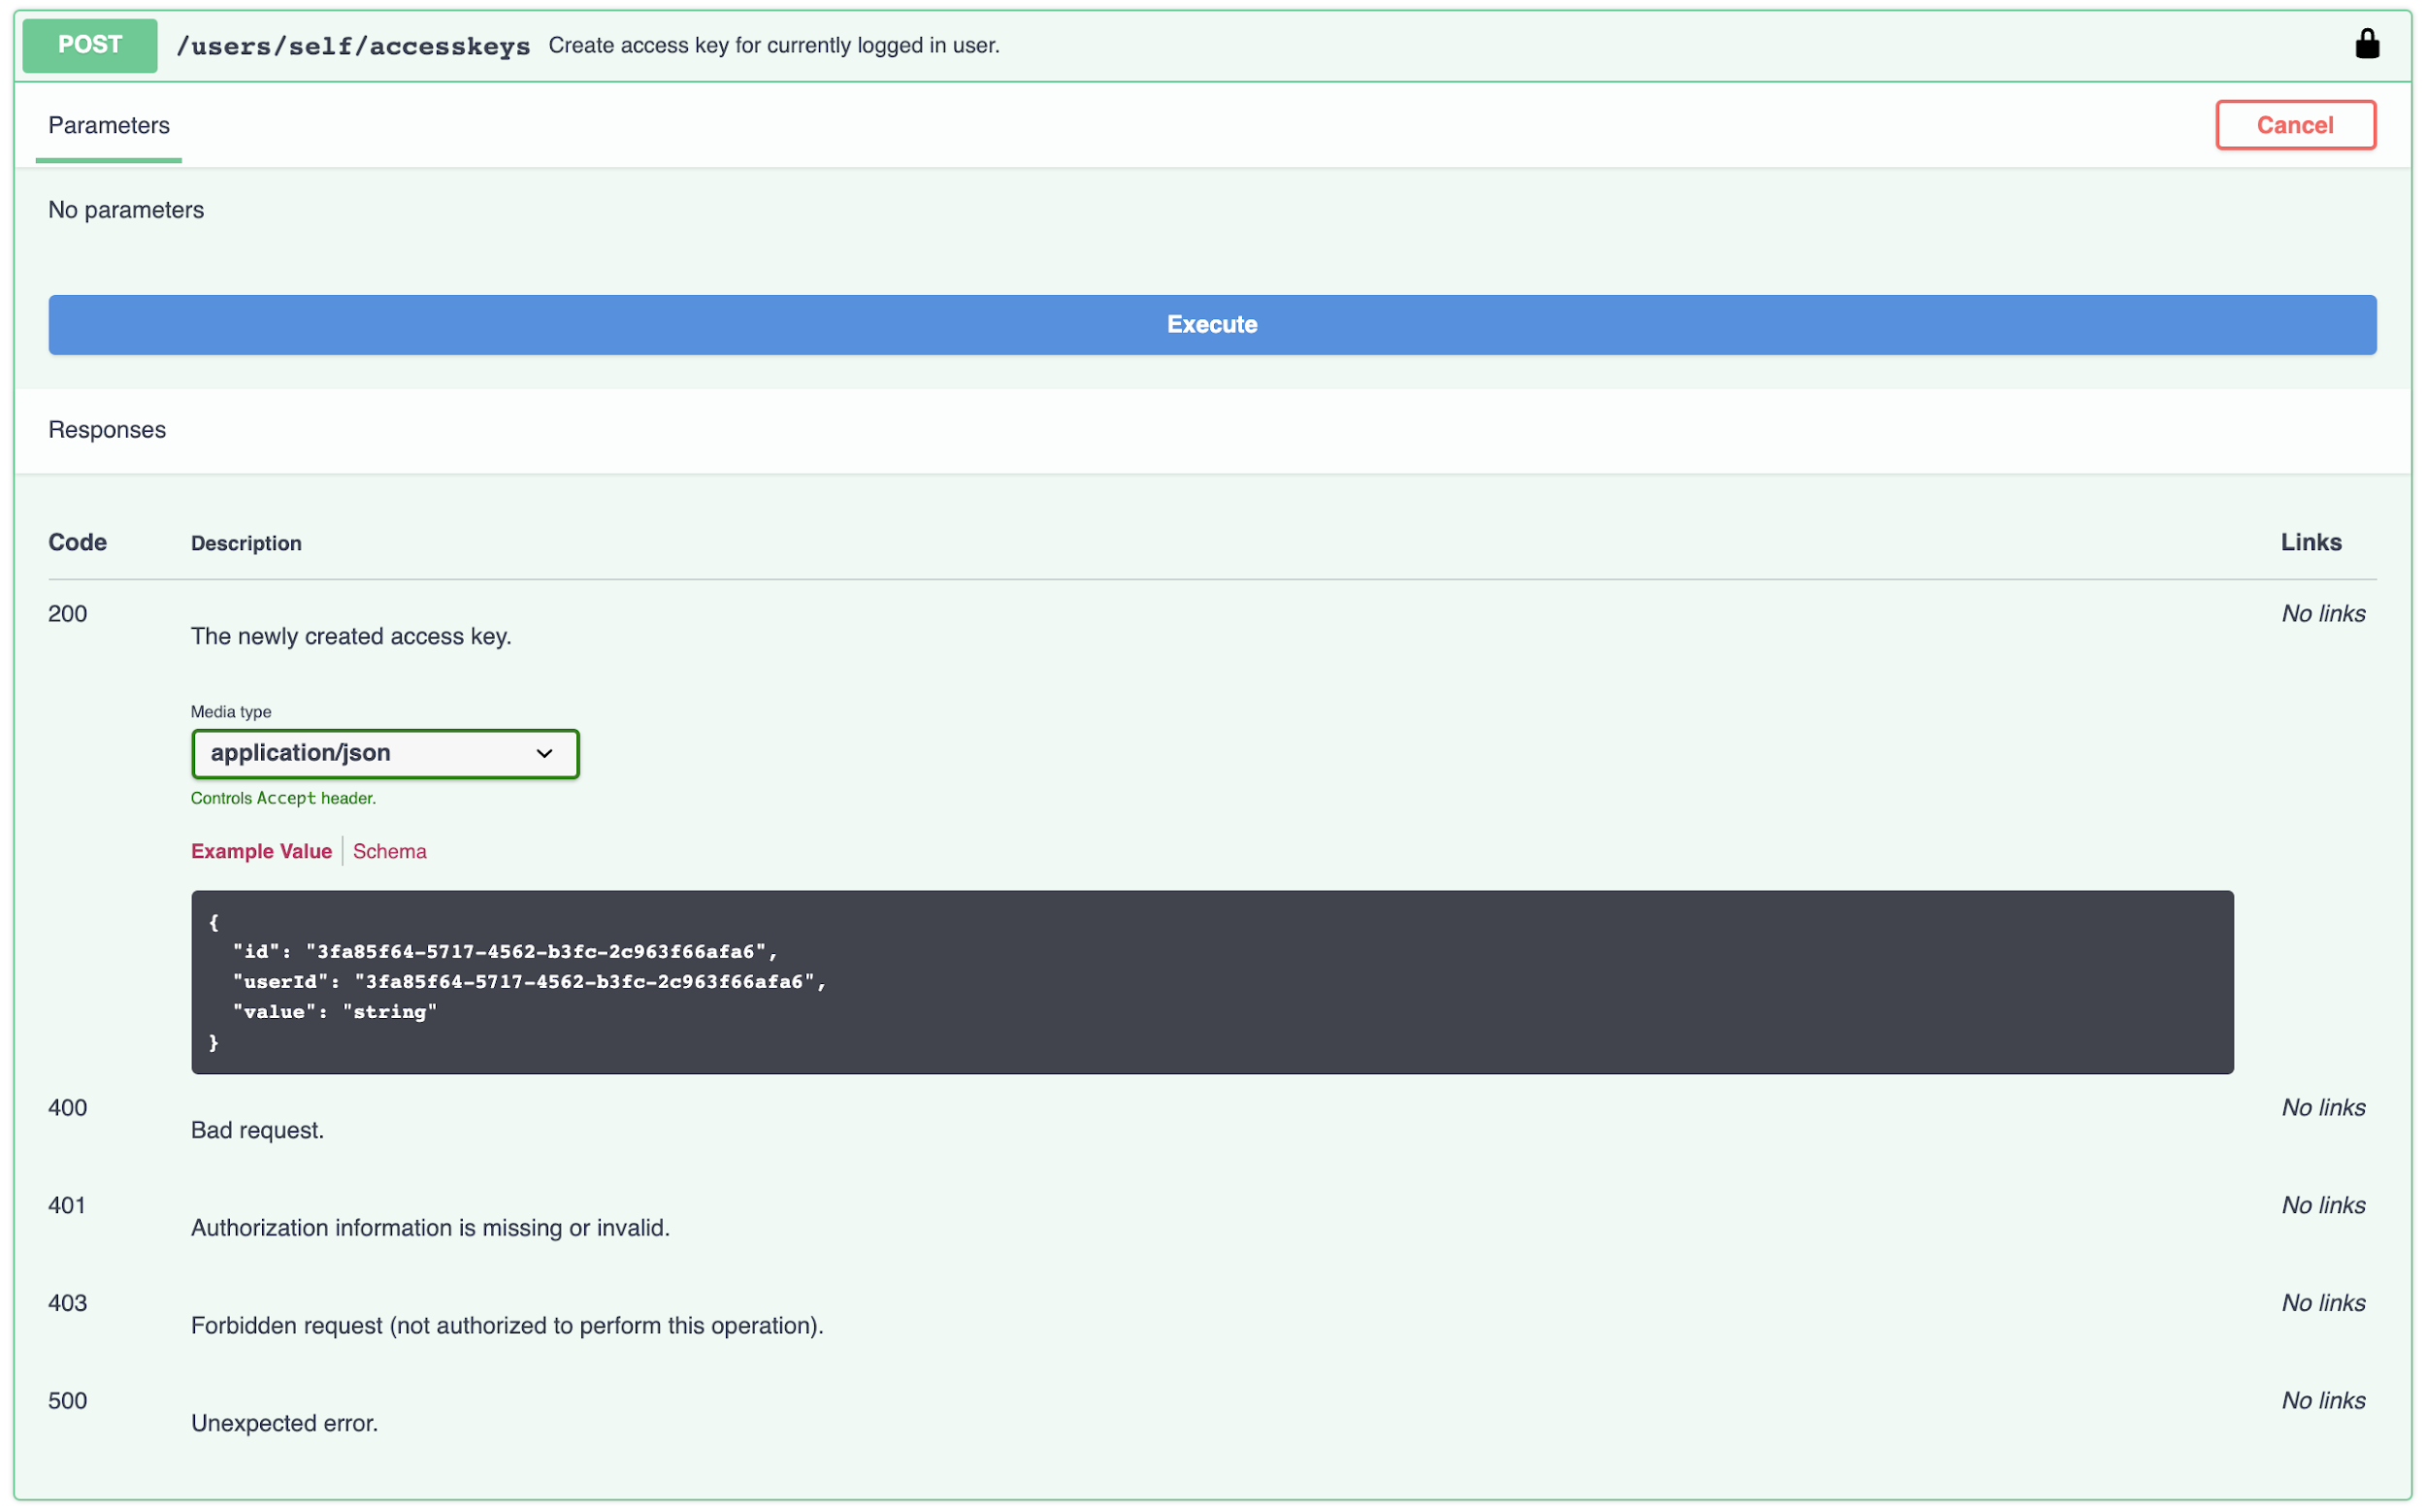

Endpoint will return you the access key in value field in response.

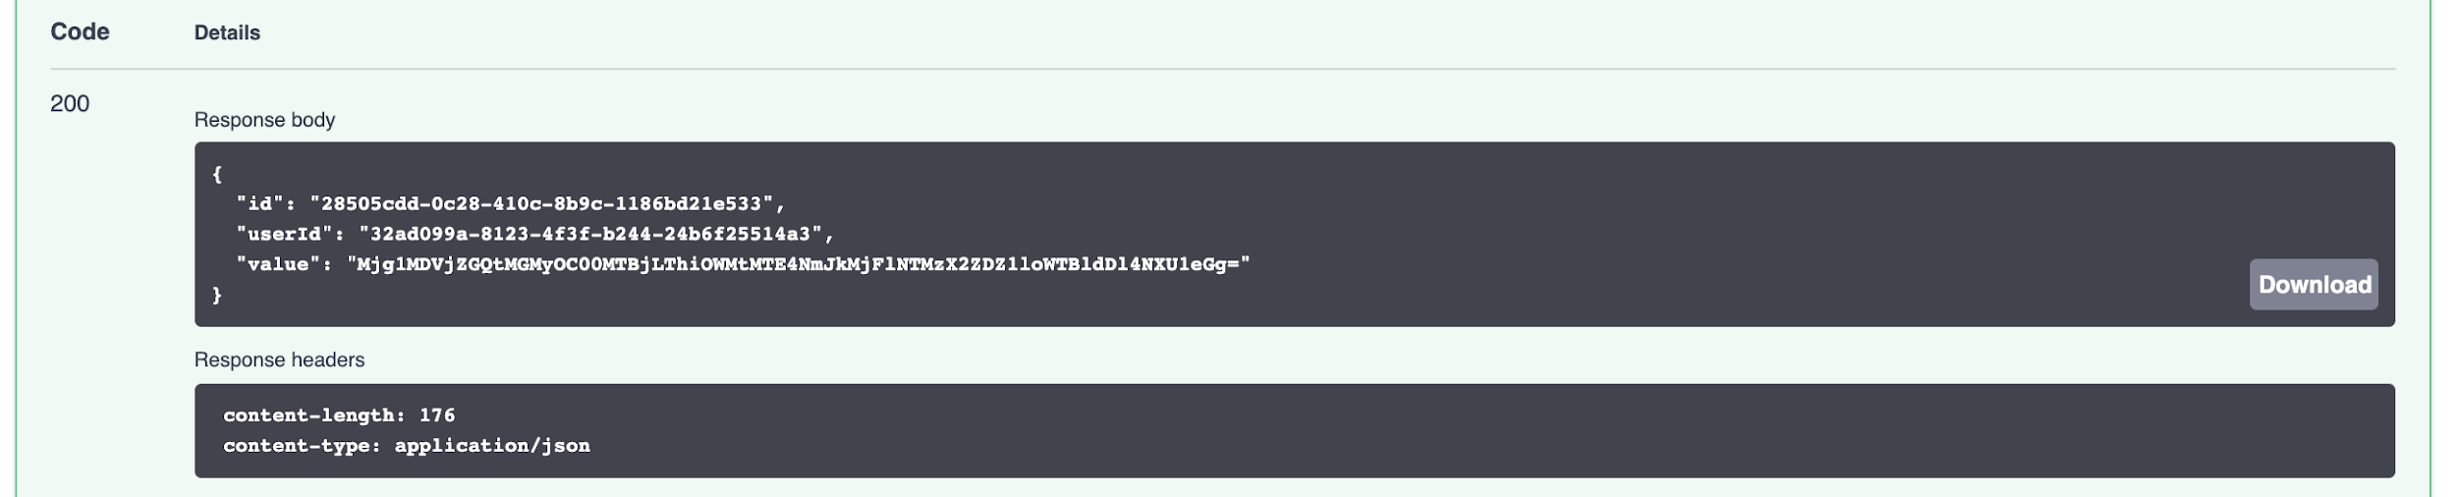
Get list of your API access keys
Endpoint: GET /users/self/accesskeys
Click “Try it out” and then “Execute” buttons in API Docs or call endpoint directly with e.g. Postman.

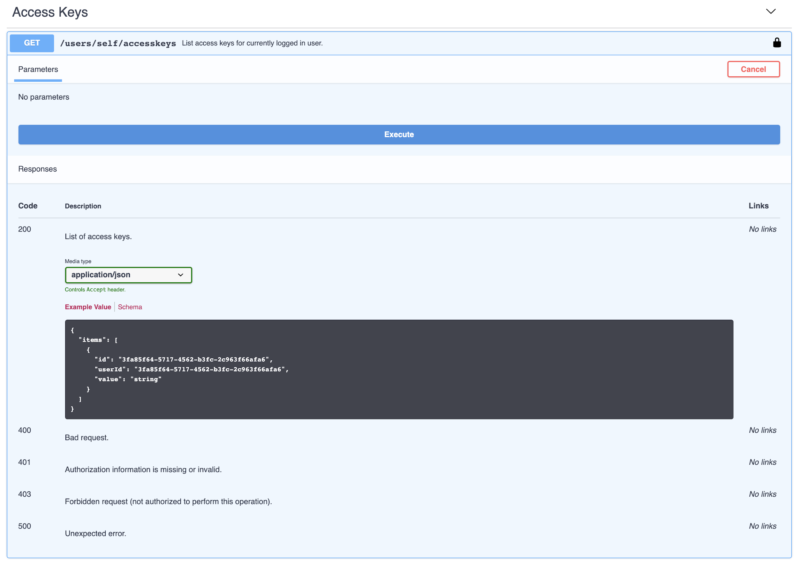

Endpoint will return you a list of your access keys.
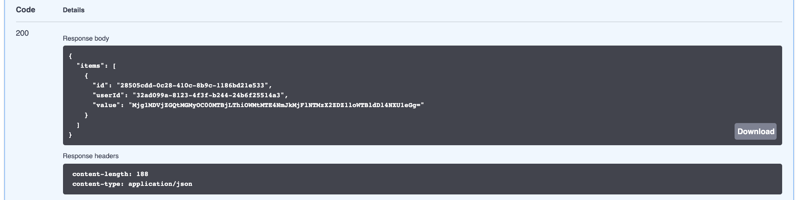

Using Portal API with access key
To integrate with Portal, API can be used with providing access key in X-Api-Key header when making API calls.

There is no need to refresh access keys. They are valid indefinitely, or as long as you delete them.

For example, to fetch measured volume for a metering site, you can use following curl command:

curl -X GET https://api.stg.gasgridportal.fi/v1/marketparties/0acc095f-7093-4d12-ae82-c67d964af442/meteringsites/66666A/volume?start=2019-10-01&end=2019-10-10&resolution=day -H "X-Api-Key: YOUR_ACCESS_KEY"

Market parties and delivery relationships
Transmission Network End Users, Retailers, Distribution System Operators and Biogas Injecting Parties give notice to which Shipper they have delivery relationship including the starting and ending date of this relationship. Establishment of delivery relationships are initiated by Transmission Network End Users, Retailers, Distribution System Operators and Biogas Injecting Parties. Shipper can accept or reject the request for delivery relationship in Portal. Shippers have no possibility to be initiating parties in this process.
With this process, TSO can have acceptance from both parties. Portal is a source of information for TSO to fulfil correct master data and for balance calculation model maintained in energy system.
Example: In the following example it is demonstrated how Transmission Network End Users, Retailers, Distribution System Operators and Biogas Injecting Parties can start the process of new delivery relationship:
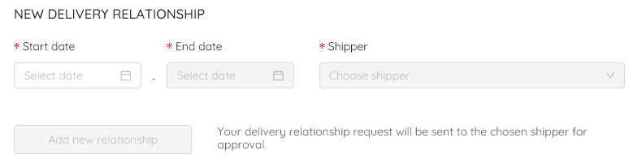
Note that the starting and ending dates follow gas days instead of calendar days. If you have agreed permanent contact, set the end date so that you will remember to update the ending date futher in the future if needed. If you need to set the ending date earlier than already confirmed, please contact TSO via e-mail (info@kaasumarkkina.fi).
The Portal will be developed so that you could set the end date box empty so that it is considered to be valid until the date is added or you inform new relationship.
Example – new delivery relationship process initiated by Transmission Network End User, Retailer or Biogas Injecting Party
Having roles of Transmission Network End Users, Retailers, Distribution System Operators and Biogas Injecting Parties, you can create new delivery relationship with shippers and check the Delivery Relationships data as follows:
- Click “Delivery Relationships” and “Metering Ponts”. The list of your metering point(s) opens:
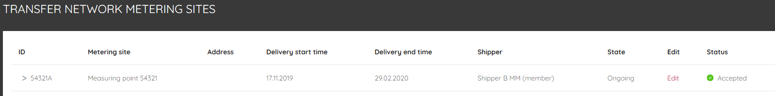
- Click “edit”
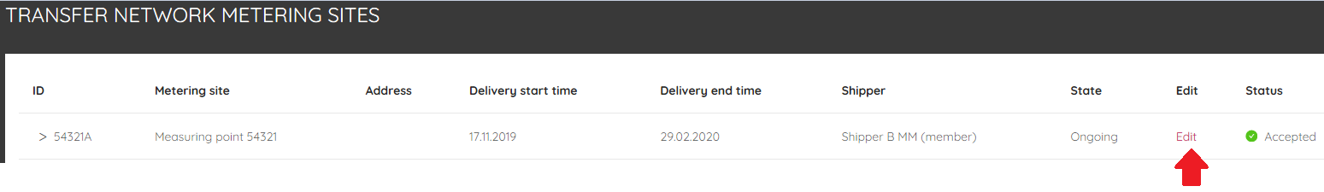
- The following window opens:
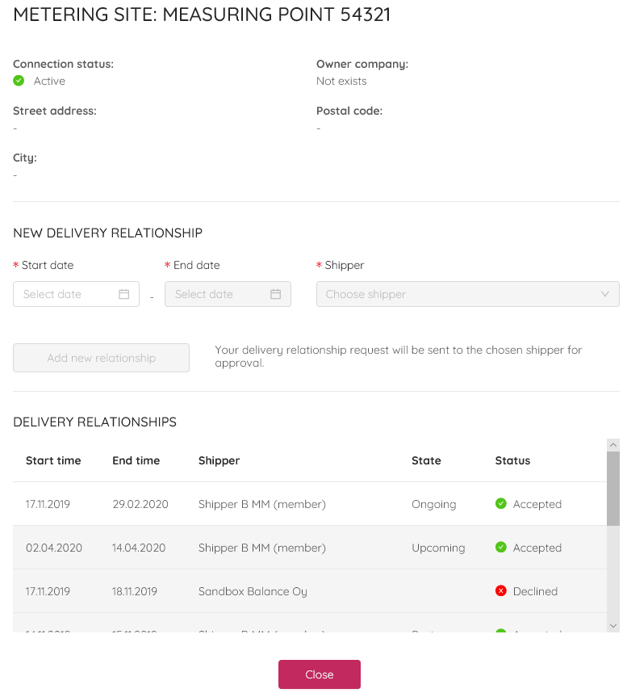
- In the example “Shipper B MM” is the shipper for the Transmission Network End User for the period 17.11.2019 - 29.02.2020. The Portal does not give possibility for the Transmission Network End User to set another shipper to deliver gas, because Shipper B MM already have ongoing delivery relationship (see below).
If you want to make changes to already confirmed delivery relationship, please contact TSO (commercial@gasgrid.fi).
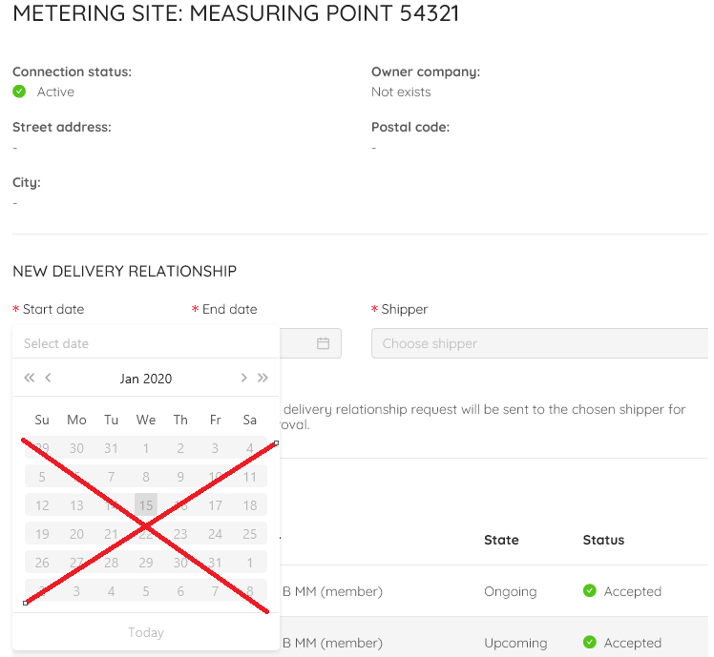
- You can find the data about ongoing, upcoming and past delivery relationships from the window above. If you have several metering points, the similar window can be opened for each metering point than described here.
Accepted delivery relationships are marked with green symbol (as seen above). If the shipper declines your request, red symbol “Decline” will appear.
“Pending” status means that your request is sent for the shipper, but the shipper has not responded to the request yet.
Transmission Network End Users, Retailers, Distribution System Operators and Biogas Injecting Parties will get a notification when the shipper has reacted to the delivery relationship request. The notification will be sent to the e-mail address you have submitted to your account.

Information about delivery relationships to be submitted in the Portal
If you have several market roles, you might have “Metering Points”, “Shippers” and “Retailers” under the section “Delivery Relationships”.
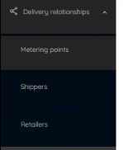

In section “Metering Points” you can find the Transmission Network End User metering points. Note that the data of Distribution Network End Users are handled in the Gas Datahub. Also the information about the connection point between Transmission Network and Distribution Network (so called ”city-gates”) are in the Gas Datahub. Thus, the delivery relationships to the Distribution Network End Users are notified by retailers to the Gas Datahub.
By clicking ”Shippers”, the Retailer may notify delivery relationships to Retailer’s shipper(s) (one or several shippers possible) which are delivering gas to the Distributions Networks. You don’t need to define which shipper is delivering gas to which Distribution Network Ens User point in the Portal, because this information is settled in the Gas Datahub.
TSO needs the information which shipper is gas to the retailer with delivery obligations. This retailer sells the loss gas for DSO.
If there are only daily read metering sites in the distribution network, distribution system operator may buy loss gas directly from the shipper. In this case DSO notifies TSO directly about the loss gas quantities. Information is maintained in gas datahub and TSO will post values also for shippers in Portal.

Delivery relationship to Shipper
Delivery relationship to Shipper is initiated by Transmission Network End Users, Retailers, Distribution System Operators and Biogas Injecting Parties. Shippers need to accept or decline the requests.
The notification shall be submitted and accepted at least three Gas Days before the first Gas Day on which the Market Participant Relationship is to apply. If the TSO has received the notifications by the above-mentioned deadline, the information about the Market Participant Relationship shall be registered in the Register of Market Participants. The TSO shall notify the participants about the registration of a new Market Participant Relationship.
Shippers can see the following data per each metering point:
- “ID” means the code of the delivery point.
- “State” describes whether the delivery relationship is ongpoing, upcoming or past. The new delivery requests from Transmission Network End Users, Retailers, Distribution System Operators, Biogas Injecting Parties is shown below. Note that only one delivery relationship can be “ongoing” for each metering point.
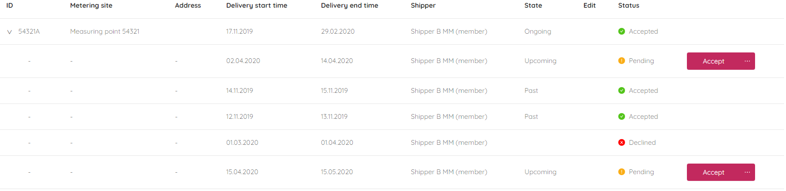

Biogas Injecting party
There may be one shipper for each of the biogas entry points in a biogas portfolio of a biogas injecting party. Therefore, there may at the maximum be the same number of shippers as there are entry points in the same biogas portfolio. A biogas injecting party shall notify the TSO via the Portal which of the entry points belonging to a biogas portfolio belong to which shipper at least three gas days before the first gas day on which the shipper information for the biogas entry point will be effective.

Retailer and retailer with delivery obligation
A retailer shall, in conjunction with a new Sales Agreement, notify to the TSO the shipper for the metering site that is responsible of the supply of gas in the retailer's consumer portfolio. The retailer may only notify as a shipper for a metering site such a shipper that has a market participant relationship to that retailer’s consumer portfolio registered in the Register of Market Participants. If a retailer wishes to change the shipper for a metering site contained in its consumer portfolio, the retailer may update the metering site’s shipper information on the Portal no later than three Gas Days before the first Gas Day on which the metering site’s new shipper information will be effective.
In retail market, retailers can use those shippers they have valid relationship. The non-daily read metering sites and losses of the distribution network in question belong automatically to the residual consumption of the retailer with delivery obligation. For the residual consumption portfolio which is maintained by retailer with delivery obligation has a delivery relationship to one shipper.
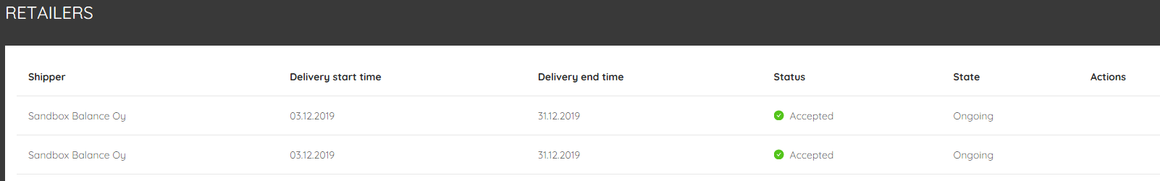

Distribution System Operator
A residual consumption portfolio of a retailer with delivery obligation and a DSO may only have one shipper, which is determined on the basis of the notified Market Participant Relationship.
If there are only daily read metering sites in the distribution network, DSO may buy loss gas directly from the shipper. In this case DSO notifies TSO about this delivery by e-mail. Information is maintained in gas datahub and TSO will submit values also for shipper in Portal.

End User in transmission network
A transmission network end user’s metering site(s) for which the transmission network end user shall notify its Market Participant Relationship with the shipper specifically for each metering site.
You can find your metering site(s): Delivery relationships 🡪 Metering points

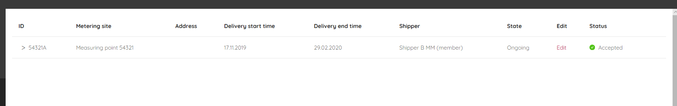

Metering site
A Transmission Network End User’s metering site(s) for which the Transmission Network End User shall notify its Market Participant Relationship with the shipper specifically for each metering site.

TSO maintain metering site coding and fullfill those in Portal (five numbers and one letter, e.g. 54321A).

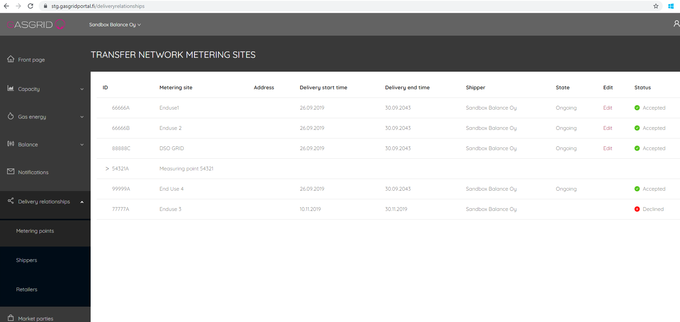

By clicking the small red arrow, you can find the data of delivery relationships which is ongoing, which are past, and which will be upcoming (see below).

Metering information API end points
Metering site volume m³n, energy kWh and heat value kWh/m³n is available via API. The metering site is the actual point to which natural gas is supplied to an End User in the gas system. Metering site is coded by TSO (example on measuring point code is 12345A). In production environment TSO links and connects registered transmission network end user metering sites into the company who has agreements with TSO.

Exit Zone covers all End Users connected to the Finnish Gas System.

End User and Shipper who delivers gas to the end point can have measuring data.
Fetch metering site measured amount in given resolution hour, day, month between given start and gas day from the beginning of gas day (Finnish local time 7:00). If you query current day, the result response includes hours that have values and TSO has ready.
The TSO shall provide each shipper with information on the shipper's actual hourly biogas network injections in the transmission network, and its hourly consumption for each transmission network end user metering site where the information is available based on near real-time metering.
GET /marketparties/{id}/meteringsites/{meteringSiteId}/volume

GET /marketparties/{id}/meteringsites/{meteringSiteId}/energy

GET /marketparties/{id}/meteringsites/{meteringSiteId}/heatvalue

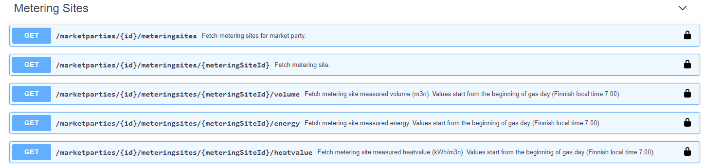
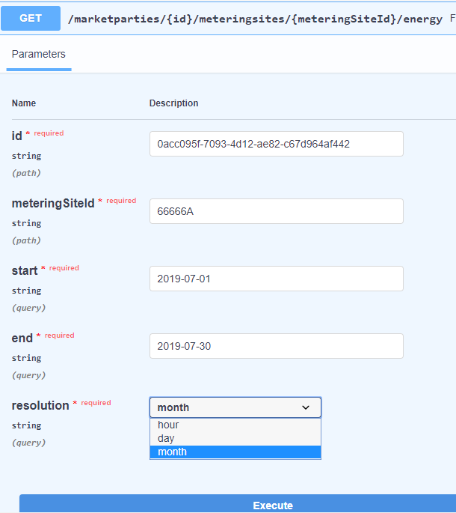

Fetch market parties for currently logged in user (API)
Globally Unique Identifier ID (API)
API endpoint called: Currently logged user 🡪 /users/self/marketparties
In staging you can have ID of Sandbox balance Oy
"id": "0acc095f-7093-4d12-ae82-c67d964af442”
This ID shall be used later in other queries.

Fetch market party data (API)

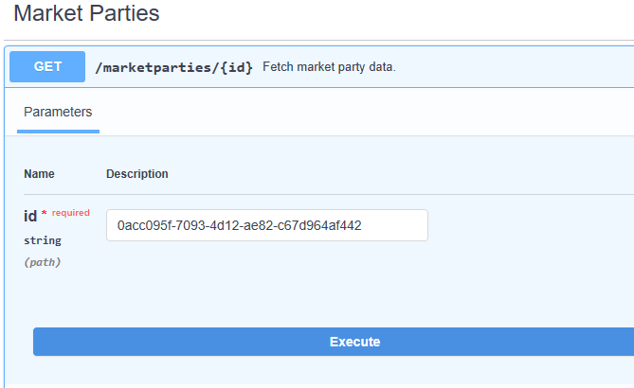
Figure: Parameter "ID"
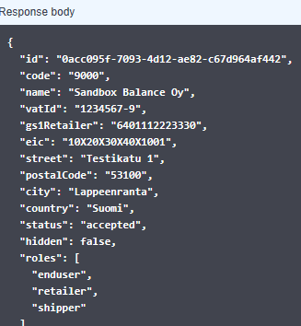
Figure: Response for Marketparties/{id}

Balance Group
Shippers and traders shall register themselves as a Balance Responsible Party or join to a Balance Group managed by a Balance Responsible shipper or trader. In portal, shippers can notify to be a balance responsible, and after TSO has accepted this role, balance responsible can maintain members and give notification to registered traders and shipper belonging to balance group. Members give notification by accepting membership. Shippers and Traders may only be a member of one Balance Group at a time. If shippers is acting as a member of balancing group, all shippers’ Market Participant Relationships shall be connected to the same Balance Group.
Shippers and traders may choose whether they want to act as a Balancing Responsible Part or as a member of the Balancing Group by ticking the box in the framework agreement of shippers and traders.

Rules for Balancing Responsible Parties and members of the Balancing Group
The Balance Responsible Shipper or Trader shall be responsible for the balancing of the virtual and/or physical deliveries and offtakes of the members of its Balance Group in a manner whereby the TSO can minimize the balancing actions undertaken while balancing the system.

Balance Responsible Shippers and Traders or the members of the Balance Group authorized by Balance Responsible Party shall submit trade notifications and nominations via the Portal concerning the changes of the gas ownerships taking place on a Gas Day.
Shippers shall make nominations of the quantities of gas delivered on a Gas Day at the Balticconnector Interconnection Point or Imatra Entry Point. Nomination shall be the condition for Gas Transfers at these points.
The gas exchange’s Transaction Clearer shall be responsible for Trade Notifications concerning trade transactions conducted on a gas exchange. This means the Portal will receive necessary information from the gas exchange so that shippers or traders are not allowed to submit trade notifications (= submit trades on the gas exchange to the VTP), because the submission is done by the gas exchange’s Transaction Clearer.

The Balance Responsible Shipper shall notify the TSO of a new Shipper or Trader becoming a member of its Balance Group no later than three (3) Gas Days before the start of the Gas Day from which the change is to take effect, providing that the Shipper or Trader becoming a member of the Balance Group confirms the amendment to its Balance Group information no later than one (1) Gas Day before the Gas Day on which the amendment takes effect.
If shippers and traders do not confirm its move into another Balance Group, the change shall not take effect and, instead, shippers and traders shall stay in its current Balance Group. Amendments to Balance Group information shall be notified on the Portal. Shippers and traders may not trade in gas energy or capacity before the information on its valid Balance Group is registered in the Register of Market Participants.
Balance Groups may be merged for the netting of imbalances and for charging the imbalance charge only to one Balance Group participating in the merger. The merger of Balance Groups shall be subject to the condition that the Balance Responsible Party has a valid Balance Group Merger Agreement with the TSO. Under the Agreement, daily imbalances occurring for each Balance Group shall be netted and invoiced to a specific Balance Group participating in the merger. If you want to merge the your Baöancing Group with another Balacning Group, please contact TSO.

Notify to be Balance Responsible Party
If you want to change the the role from a member to a Balancing Respnsible Party, you can create the new Balance Group in the Portal as follows:
Click “Balancing” 🡪 Click “New Balancing Group” 🡪 Fill the following sheet.

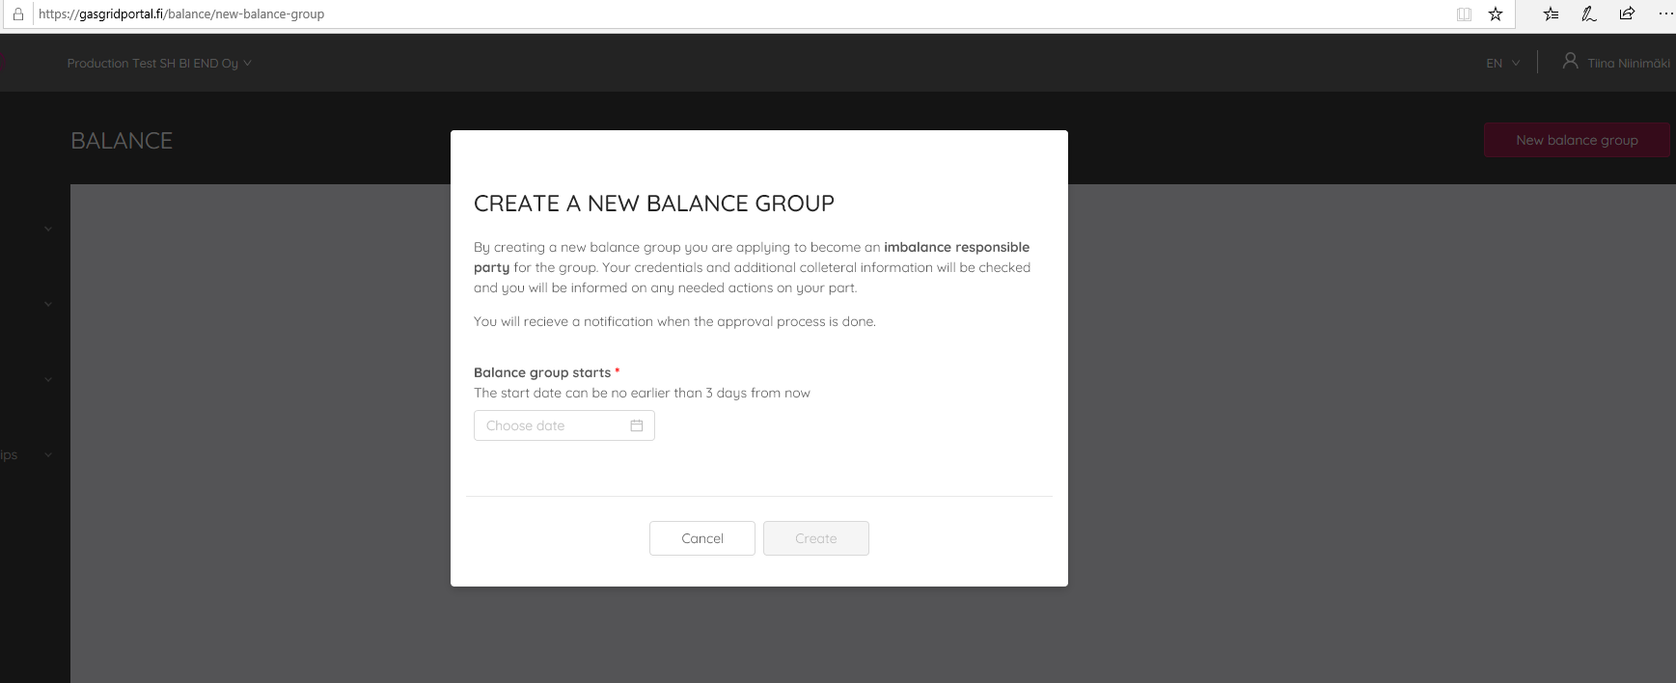
Figure: New balance group notification, being a balance responsible shipper or trader.
If you are acting as Balancing Responsible Party and you want to change your role of a Balancing Group member, please contact TSO (info@kaasumarkkina.fi).

The Balance Responsible Party will see the following window:
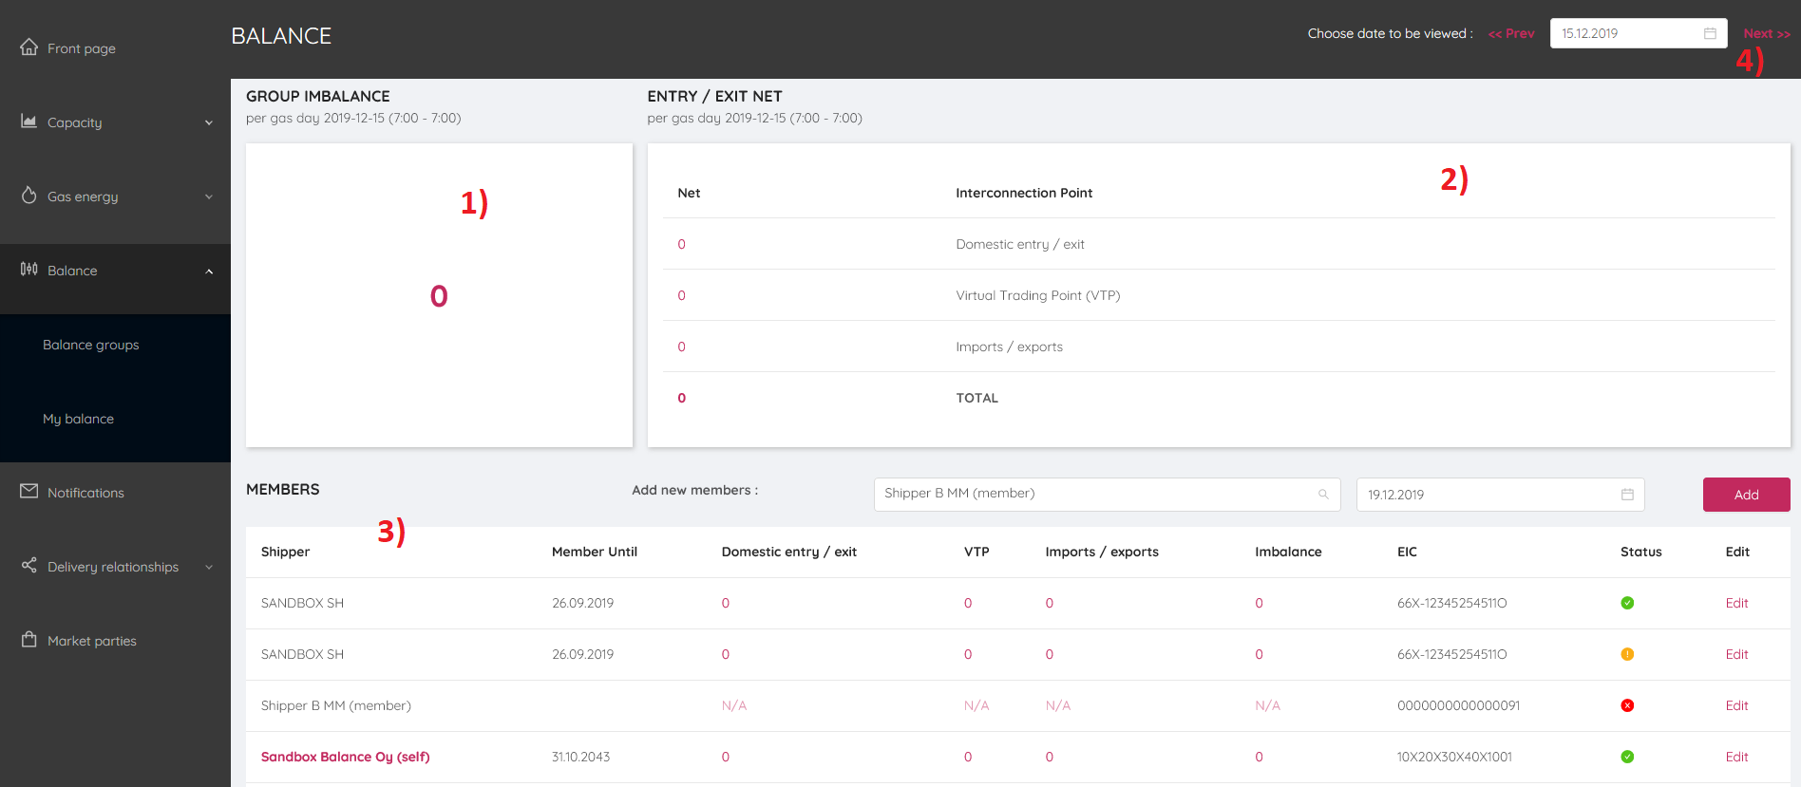

- Group Imbalance
- Entry/Exit Netted
  - for Domestic exit/biogas entry
  - VTP
  - Imports/Exports
  - Total
- Members of the Balancing Groups
- You can choose the date for which you want to check the balance date.

Notify to be a member of Balancing Group

The notification to be a member of Balancing Group is made by the Balance Responsible Party. If you are a Balance Group member, you need to contact Balancing Responsible Party who will start the process which results a membership to the Balance Group.
As a Balancing Responsible Party, you can add member as follows:
- Click “Balancing”
- Choose the shipper or trader who wants to be a member of your Balancing Group. Choose the date when the member will be part of your Balancing Group.
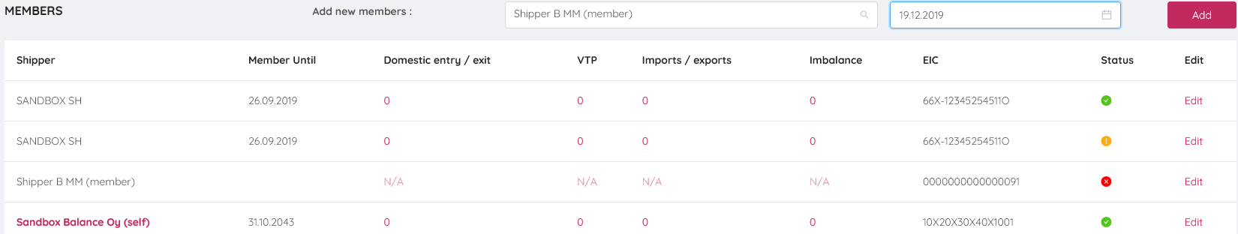
- You will receive a notification from Balance Responsible Party.
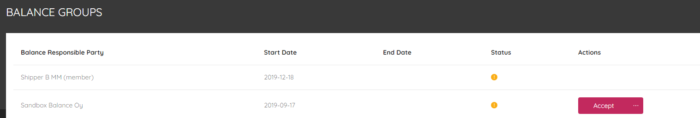

- Balance Repsonsible Party will receive notification about the acceptance.
- Balance Responsible Party may set the ending date of the membership of the member of Balancing Group as follows:
- Click “Edit” for the member you want to make changes.
- The following window opens:
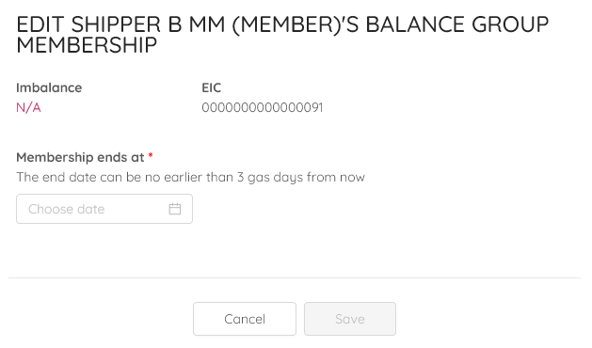

Capacity (relevant for shippers)
Capacity is booked via Portal in Finnish gas market. Shippers are entitled to book capacity from TSO. Capacity shall be allocated to shippers by way of the first-come, first-served (FCFS) procedure for the Imatra Entry Point, Biogas Virtual Entry Point and Exit Zone. Allocation of capacity for the Balticconnector Entry and Exit Points shall be implicit based on confirmed nominations, and in case of congestion, pro rata is applied.

Capacity Booking
By clicking “Capacity”, the overview page opens. The window includes:
- Your latest capacity bookings
- Your latest notifications on capacity rights transfers (section 6.2.)

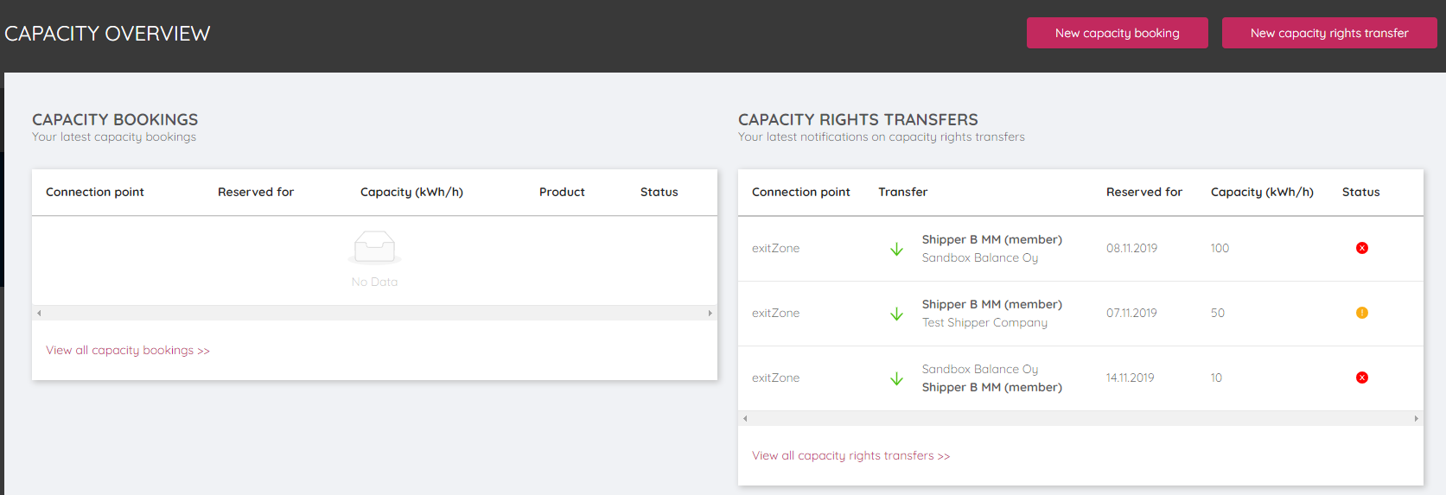

Booking process

- Click ”new capacity booking”
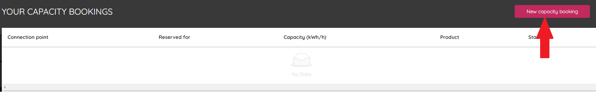

- Capacity can be booked for the exit zone, Imatra connection point and Biogas entry point.

Note! At Balticconnector, implicit capacity allocation principle is applied. Balticconnector capacity is allocated based on confirmed nominations, so only nominations are submitted. Further guidance about Balticconnector nominations can be found from section 7.2.
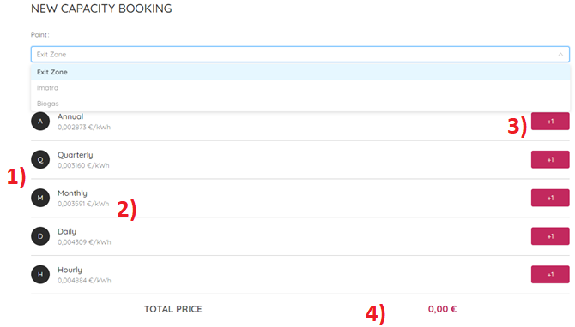

- Annual, quarterly, monthly, daily and within-day capacity can be booked. The booking windows are defined in the rules for gas transmission. Note that there are differences in the capacity periods in different entry and exit points. Please check carefully the content of chapter 5 of rules for gas transmission.

- The unit prices are described for each capacity product in the Portal. The Portal calculates the non-binding total price of the bookings you are intended to do.

- By clicking red “+1” box, you can submit capacity booking request.

- The Portal calculates the total price of your intended bookings.

- Book capacity products

Set the starting time from which you want to activate the capacity product. Depending on the capacity product, you need to set the ending time too. Set the amount of requested capacity in unit kWh/h. The Portal calculates the non-binding sum about the charges incurred by the capacity booking. The tariff period is calendar year and therefore the duration of some capacity products may exceed the current tariff period. In these cases, the price given by the portal is only indicative.
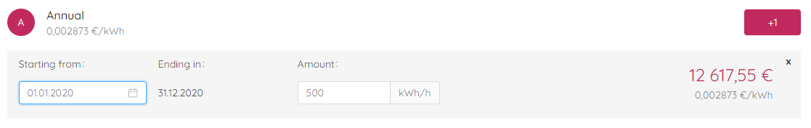
Note that there are differences in the offered capacity products in different entry and exit points. For instance, annual capacity can be booked from the beginning of each gas month at the exit zone and biogas entry points, while at Imatra point annual capacity can be booked only from the beginning of October each year. In 2020, the annual capacity product for Imatra point is only 9-month product, because the gas year ends in the end of September.
If the shipper has several Capacity Agreements for the same Entry Point, Exit Point, Biogas Virtual Entry Point and the Exit Zone, the Shipper may pool the capacities under these Capacity Agreements to the extent that such Capacity Periods overlap. This means, you have possibility to submit several bookings for each capacity products. For instance, at the exit zone, if you submit 100 kWh/h annual capacity booking and 150 kWh/h annual capacity booking for the same period, portal calculates that you have 250 kWh/h annual capacity.
When TSO is accepted your capacity booking, the final and binding Capacity Agreement shall be available on the Portal.

Capacity information shippers receive from the Portal
Shippers shall have registered one or more Contact Persons on the Portal, if the shipper wants to use the booking procedure to submit capacity bookings and conclude Capacity Agreements.
A booking request accepted by the shipper shall be regarded as binding as soon as it has been accepted by the shipper’s Contact Person.

Transferring of capacity rights

Capacity right transfers during one or more Gas Days can take place from a shipper (Transferring Shipper) to another (Receiving Shipper) via the Online Capacity Transfer System maintained by the Portal.
By clicking “Capacity Right Transfers” the following window opens. The window contains the overall situation with your capacity rights transfers:
- Processed capacity right transfers
  - Confirmed capacity right transfers (market with green symbol)
  - Unconfirmed (declined) capacity right transfers (market with red symbol)
- Unconfirmed capacity right transfers, which means the counterparty shipper has not replied to your transfer request (market with yellow symbol)

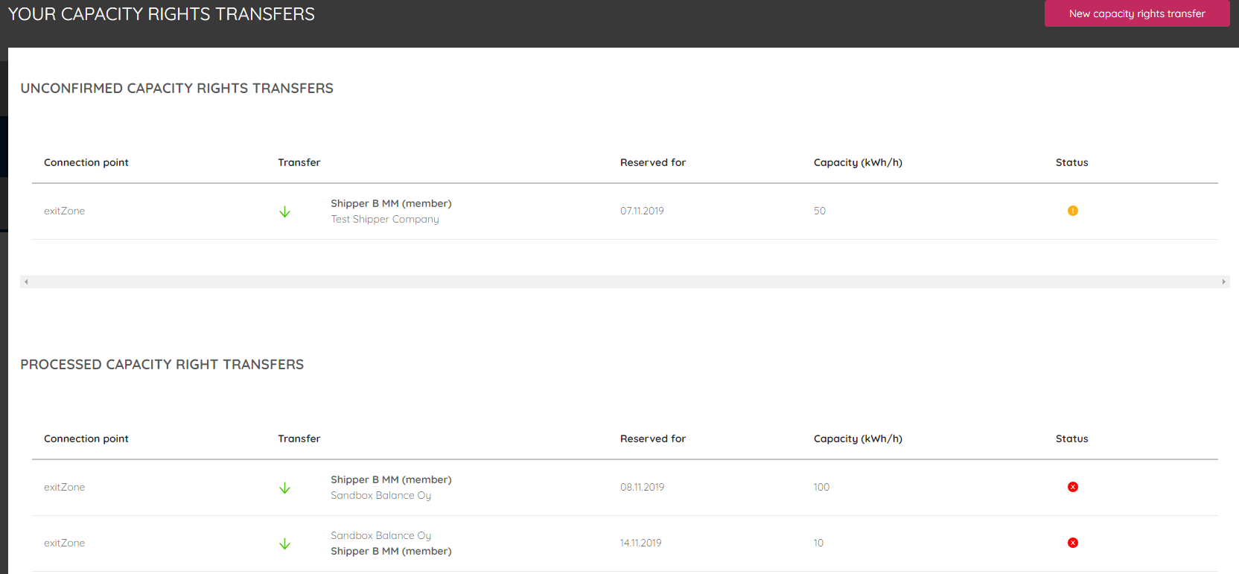

Process step by step:

- The selling party submits capacity right transfer request and defines the party who will be the counterparty shipper (buying shipper).
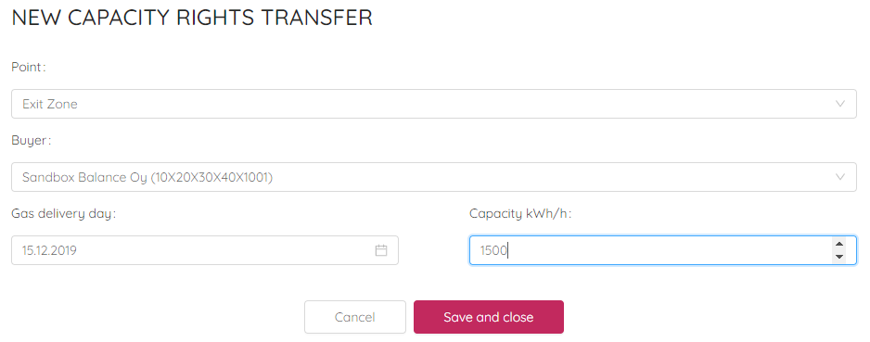
The Initiating Shipper shall send the capacity right transfer request using the Portal. The Counterparty of the Initiating Shipper (the Responding Shipper) shall whether confirm or reflect the capacity right transfer. The Responding Shipper will receive a notification from the Portal when Initiating Shipper have submitted the capacity right transfer request.
When the Responding Shipper has confirmed the request, the TSO shall check whether or not the confirmed capacity right transfer request meets the conditions (the transferring shipper has sufficient capacity/the receiving shipper does not have a sufficient credit limit). The Portal notifies the Participants about accepted capacity right transfer request with green symbol. “Waiting for TSO action” means that TSO has not confirmed the capacity right transfer.
The shippers may request that capacity right transfers carried out by them should be amended or cancelled by notification to the TSO by e-mail (info@kaasumarkkina.fi). The TSO shall check in conjunction with a request that the receiving shipper has not made any confirmed nominations that would prevent the amendment or cancellation of the capacity transfer.

Overrun in Exit Zone and Biogas
If shippers have not booked capacity enough, and their consumption exceeds the allocated capacity, shippers are obliged to pay capacity overrun charges in exit zone and biogas entry points according to the price list on the TSO’s webpage.
In exit zone: Based on the results of the final balance settlement, offtake from the system in the exit zone exceeds the shipper’s total capacity for each gas day in the exit zone, the shipper must pay capacity overrun charge.

In biogas virtual entry point: Based on the results of the final balance settlement, injection into
the system at the biogas virtual entry point exceed the shipper’s total capacity for each gas day at the biogas virtual entry point, the shipper must pay capacity overrun charge. Note that capacity is checked on a daily basis. Thus, you can book capacity during the gas day so that you have enough capacity to cover the offtake gas quantities or biogas injection.

Available Capacity (firm and interruptible)
Information about the expected capacity limits at a given Entry or Exit Point at any time in respect of firm and interruptible capacity shall be available on the Portal. Interruptible capacity is offered only at Imatra point, if all firm capacity is sold out.

Energy
Key functionality on the Portal is the submission of nominations, renominations and trade notifications which are required at the VTP, Imatra point and Balticconnector. Note that trade notifications can be submitted in the same place in the Portal than nominations by choosing “VTP” as shown below with red arrow.
Also, the renominations can be submitted under the “Nomination” section in the Portal.

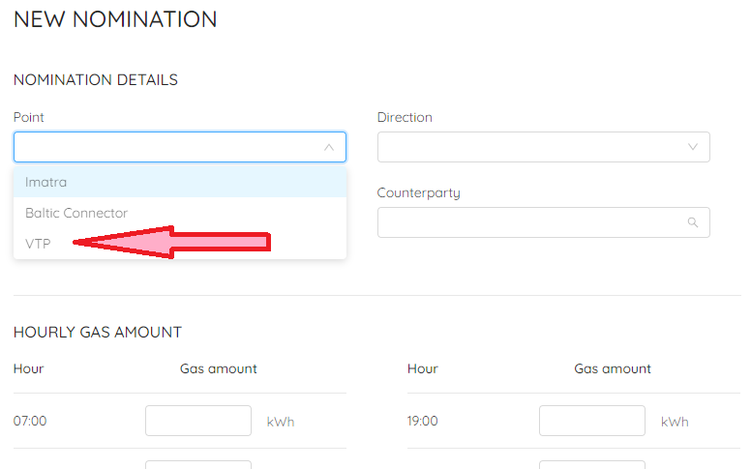

In the screenshot below you can see the overview of your nominations and trade notifications. Note, that “Nomination Intentions” describes the status of you nomination before the matching process which is performed before the nomination can be confirmed.
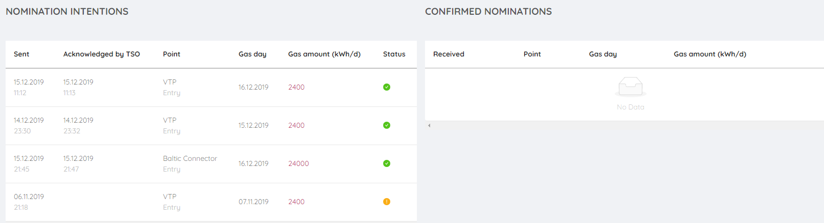
“Nomination intentions”
Green symbol = Backend System of TSO has received your nomination. Note, nominations are not confirmed yet. Nomination is confirmed when it is in the “Confirmed Nominations” box.
Yellow symbol = Processing ongoing, Backend System of TSO has not yet received your nominations. Contact immediately to TSO commercial@gasgrid.fi.
Red symbol = Backend System of TSO is not able to receive your nomination. Red colour points of some kind of error, please contact commercial@gasgrid.fi

Trade Notification
You can submit trade notification to inform TSO about the change of ownership of gas.

The trade notification process:
- Click “Gas energy” 🡪 Click ”Nominations” 🡪 Click “New Nomination”
- Choose VTP
- Choose the direction: by submitting trade notification the ownership of gas is changed. Entry means that gas ownership will be transferred for you from another shipper or trader. Exit means that gas ownership will be transferred from you to another shipper or trader.
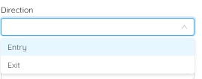
- Submit the gas delivery day
- Set the counterparty shipper or trader
- Set the gas quantities: if you set the values so that the quantities are the same each hour during the gas day, you can press “red sheet” icon to copy the same value for all 24 boxes.
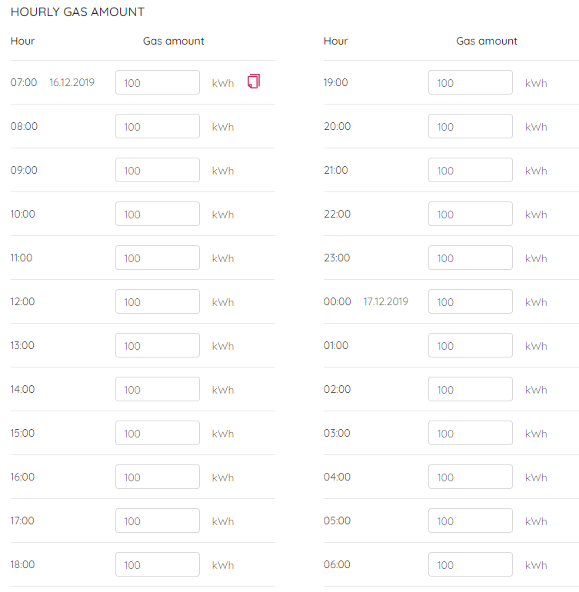
- Before the trade notification is valid, counterparty must accept it. If the counterparty has not responded to your trade notification request, the Portal shows yellow symbol. The Portal calculates the notified quantity as kWh/d. In this example 100 kWh/h was submitted which equals to 2400 kWh/d.

About the submission of trade notifications
Please note that you have possibility to choose whether you submit trade notification shared for each hour of the gas day or you set the gas quantity for the last hour of the gas day. You can also set values for the past hours of the gas days, because trade notifications are not about physical deliveries, but changes of ownerships. It is very important that you and your counterparty have submitted same values for same hours so that submitted trade notifications can be accepted as such in the matching process. You need to communicate the values of trade notifications carefully with your counterparty, because Lesser rule is applied.

Example: You have submitted a trade notification. You have notified 2400 kWh/h for the very last hour of the gas day which is acceptable by TSO to set all quantities to very last hour when trade notifications are submitted. Your counterparty has misunderstood the way you have submitted the trade noitification, and the counterparty submits 100 kWh/h for all 24 hours of the gas day. You and your counterparty have submitted trade notifications of 2400 kWh/day, but the submitted hourly quantities differs. Because of lesser rule, only 100 kWh/h for the very last hour of the gas day is accepted.
The TSO shall process and confirm new trade notifications received at half-hour intervals starting from 15:00 EE(S)T on the day preceding the Gas Day. For example, a trade notification received on a Gas Day at 13:25 shall be processed and confirmed by 14:00 and one received at 13:35 by 14:30. The TSO shall confirm the following information to both the transferring and the receiving shipper.

Nomination at Balticconnector
At Balticconnector capacity is allocated impolicitly based on confirmed nominations which means that shippers need only to nominate to get gas transported through Balticconnector. Double-sided nomination principle is applied which means that both the shpper active in Finnish market area and the counterparty shipper active in Estonian-Latvian market area need to submit nominations. TSOs in Finland and Estonia compare the submitted nominations. If the values differ, lesser rule principle is applied which means the lower of the hourly nominated values are processed in the matching process.
Nominations and renominations in Balticconnector have to be equal (“flat”) for each effective hour of the gas day (effective hour = hours of the day for which a nomination can be effective excluding lead time). If you want to renominate during the gas day at 11:27 am, the renominations will be activated at 14:00. It is not allowed to set the values so that you set renominations with great values for few last hours of the gas day.
Nominations are about requests of gas quantities which shall physically be transported. Thus, you are not allowed to nominate for past hours. TSO sets the capacity for Balticconnector which is available for shippers.
The offered capacity (= nominable quantity) is reducing every hour during the gas day, because of the capability of physical transportation.
Example – thecalculation principle how much capacity is offered during Renomination Cycles:
Let’s assume that there are no any renominations submitted during the gas day to demonstrate the principle how TSO offers capacity at Balticconnector. Note that at Balticconnector, when speaking about capacity, it means also the capability of shippers to nominate due to implicit capacity allocation.
There is 2400 kWh/h available capacity at Balticconenctor in the beginning of the Gas Day. This means, the gas quantity which can be renominated in the renomination cycle 4:00 am - 5:00 am is 2 400 kWh/h. Take into account, the lead time which is neededfor processing the nominations. Due to the lead time, the renominations submitted in the renomination cycle 4:00 am – 5:00 am can be activated from the beginning of the Gas Day at 7:00 am.
Due to the physical limitations the renomianted quantity will be 2 300 kWh/h in the renomination cycle 5:00 am – 6:00 am, and 2 200 kWh/h in 6:00 am – 7:00 am and so on. Available capacity is 100 kWh/h for the very last hour of the gas Day. This means, you are not allowed to do profiling so that you nominate greater quantities for last hours of the gas day instead of nominating flat profile.
The screenshot below is taken 15th of December at 11:48 am. If you want to submit renominations, the Portal allows you to set the values so that the nomination is activated at 14:00 pm, because of the lead time which is needed to perform matching process by TSO together with Estonian TSO.
The Portal operates in hourly basis. If you have agreed with your counterparty the nominated quantity on a daily basis, you need to divide them to the hourly values.
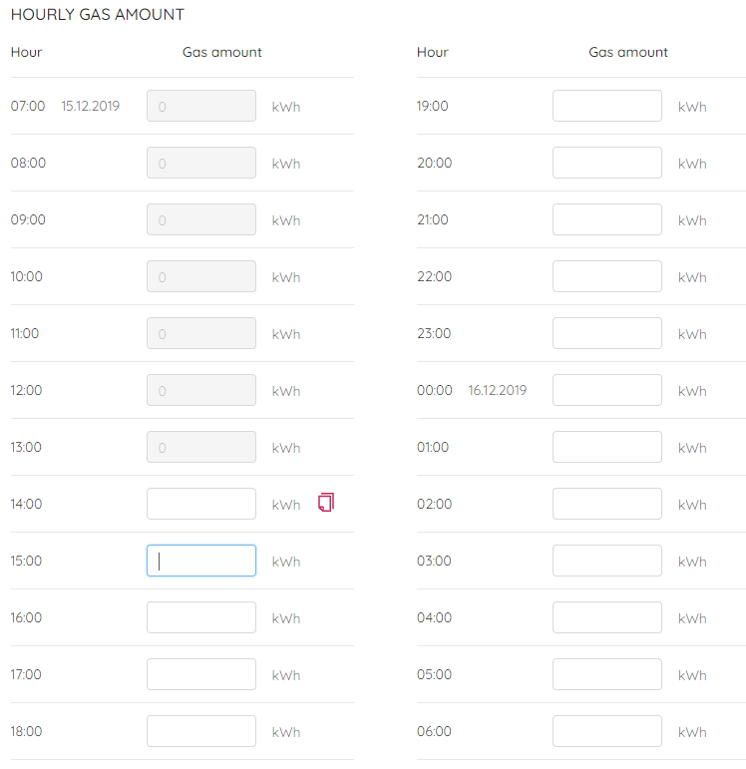
Note, if you want to renominate downwards, you must take into account that there is an underutilization fee applied if you surrender gas quantities more than defined in the price list of TSO.

If yours and your counterparty’s nomination is reduced due to congestion, and during Renomiantions Cycles some other shippers surrenders capacity, you or your counterparty is allowed to submit single-sided nomination to increase the nominated quantity closer to the initially requested nomination. TSO checks that the single-sideed nominations does not excess the initially requested renomination by comparing the single-sided nomination to initially requested
Example – how single-sided nomination principle works if there has been congestion and some shippers have surrendered capacity
Shipper A and shipper B is the shipper pair. Shipper A and shipper B renominates 500 kWh/h. The renominations is reduced to 250 kWh/h due to congestion. During latter renomination cycles other shippers have surrendered capacity. Shipper B has noticed this, and shipper B renominates 500 kWh/h to get the initially requested renomination (500 kWh/h). TSO checks and confirms this single-sided renomination, because there is capacity enough available. Thus, shipper A and shipper B have confirmed nomination of 500 kWh/h.

Nomination at Imatra
At Imatra point you must have sufficient capacity booked in order to submit nominations. Your nominations and renominations may not exceed your pooled capacity at the Imatra entry point. If a nomination or renomination exceeds your pooled capacity, TSO shall decline the nomination or renomination.
At Imatra point, there are no counterparty shippers on Russian side. Thus, you are not able to fill this box in the Portal as seen below.
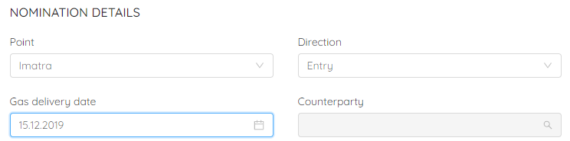

Confirmed Nominations
On Gas Day D-1 by 17:00 EE(S)T, the TSO shall notify to the shipper:
  - whether nominations for Gas Day D have been confirmed
  - whether one or more of the nominations have been reduced or declined.
Confirmed reominations shall take effect on the third full hour following receipt of the renomination. For example, a renomination received on a Gas Day at 22:50 EE(S)T shall therefore take effect at 1:00 EE(S)T, and a renomination received at 23:10 EE(S)T at 2:00 EE(S)T.

Nominations which have been confirmed as such or reduced shall be Confirmed Nominations.

Nomination (API)
Please check out the instructions for using API here: https://gasgridportal.fi/apidocs. Authentication is needed to access API Docs in the Portal.
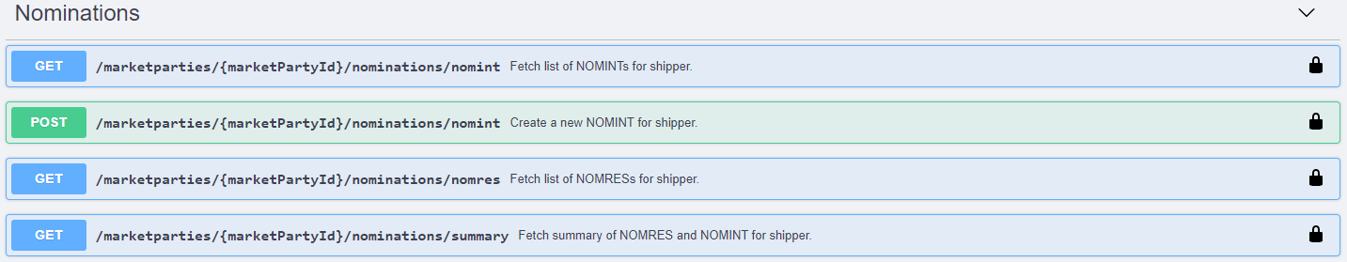

Balance information
The Balance Responsible shipper or trader can have in Portal the following information for each member of its Balance Group on Gas Day:
- Day-specific sum data (kWh/d) for a Balancing Group members’ latest confirmed nominations for Gas Day D (netted deliveriesofftakes without counterparty information). The data shall be updated by the hour.
- Day-specific sum data (kWh/d) for a Balancing Group members’ latest Accepted Trade Notifications for Gas Day D (netted deliveries-offtakes without Counterparty information). The data shall be updated by the hour.
- Hour-specific sum data (kWh/h) for the measured transmission quantities (netted deliveries-offtakes without Entry and Exit Point data) of all of the Balancing Group members’ Biogas Entry Points and Exit Points connected to the Transmission Network.
- Imbalance
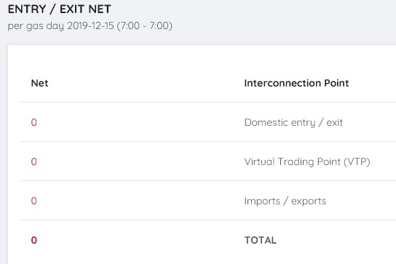
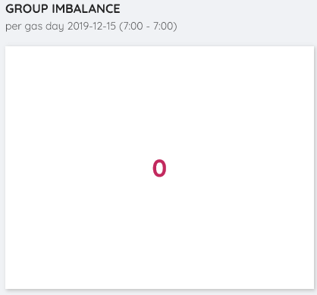

The Balance Responsible Party may see the following data from the Balance Group members:
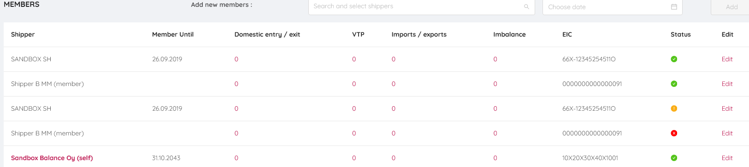
Only the sum data is seen by the Balance Responsible Party.

Data provided for Balance Responsible Parties by TSO
The data on the measured transmission quantities shall be submitted by the next full hour after the end of each delivery hour by TSO. The measurement data is updated once per hour. Please note: Measurement data submitted during the day is Unvalidated Data and does not constitute any Allocation confirmed by the Transmission System Operator with System Responsibility.
The measurement and balance position data will be available to Balance Responsible Parties as hourly time series containing the data from the start of the Gas Day until the latest hour for which data is available. The hourly time series for the data will be available via the Portal. The data shall be stored for 12 months.
Note that only metering data from the Transmission Network End Users is shown in the Portal, the data from “city-gates” (connectrion point between transmission and distribution networks) is not shown in the Portal.
The Portal will show the updated green zone of the gas system for that Gas Day. The green zone is the zone within which the system’s imbalance forecast for the Gas Day may vary before the TSO will carry out balancing actions within the Gas Day by buying or selling gas on a gas exchange. On the Gas Day from 7:45 TSO publish on its Portal the Gas System’s forecast imbalance for the Gas Day and update this forecast every hour until 3:45.

Balance Responsible’s data
If the sum of the Balance Group’s injected quantities of gas on a Gas Day is not equal to the sum of the Balance Group’s offtake for the Gas Day, the Balance Group shall be deemed imbalanced and the Balance Responsible Party of the Balance Group shall pay charges or receive compensation for imbalance quantities depending on the direction and amount of the imbalance.
The Balance Responsible Party shall receive from the TSO the following information for each member of its Balance Group within the Gas Day D-1:
- Day-specific sum data (kWh/d) for a Shipper member’s latest Confirmed Nominations (netted deliveries-offtakes without Counterparty information). The data shall be updated by the hour.
- Day-specific sum data (kWh/d) for a Shipper or Trader member’s latest Accepted Trade Notifications (netted deliveries-offtakes without Counterparty information). The data shall be updated by the hour.
- Hour-specific sum data (kWh/h) for the measured transmission quantities (netted deliveries/offtakes without Entry and Exit Point data) of all of the Shipper member’s Biogas Entry Points and Exit Points connected to the Transmission Network. The data on the measured transmission quantities shall be submitted by the next full hour after the end of each delivery hour.

The Balance Responsible Party may see the following data from the Balance Group members:
Only the sum data is seen by the Balance Responsible Party.

Please note: Measurement data submitted within the day is Unvalidated Data and does not constitute any allocation confirmed by the TSO.
The data presented above shall be available to Balance Responsible Parties as hourly time series containing the data from the start of the Gas Day until the latest hour for which data is available. The hourly time series for the data shall be available via the Portal. The data shall be stored for 12 months.

Each Shipper’s or Trader’s balance
Each shipper or trader may see the balance information of their own from the Portal (see below).
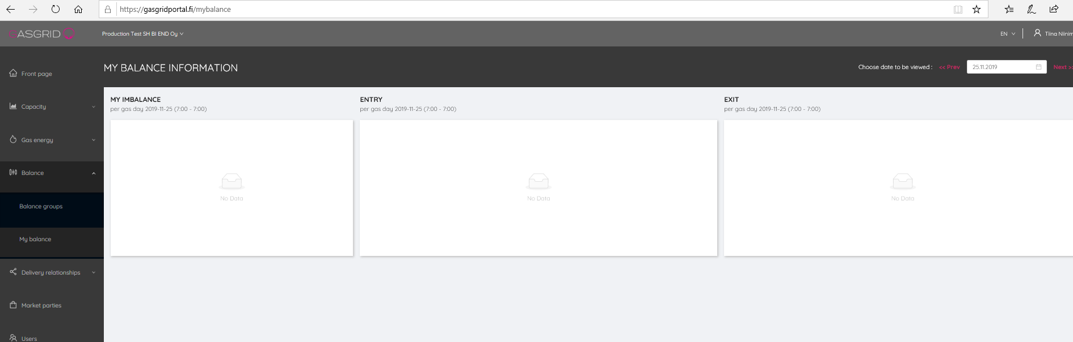
The balance information provided by the Portal: Imbalance, entries and exits.
The TSO shall provide each Shipper with information on the Shipper's actual hourly biogas network injections in the Transmission Network and its hourly consumption for each Transmission Network End User Metering Site where the information is available based on near real-time metering. The information on actual quantities transmitted shall be provided by the next full hour after the end of each delivery hour. Also, the balance position of the Shipper or Trader is shown in hourly basis. The information of each hour is shown within one hour from the end of the previous hour.
By the start of the Gas Day at 7:00 EE(S)T, the TSO shall publish on its Portal the green zone of the gas system for that Gas Day. The green zone is the zone within which the system’s imbalance forecast for the Gas Day may vary before the TSO will carry out balancing actions within the Gas Day by buying or selling gas on a gas exchange.

Balance (API)

Instructions to API:
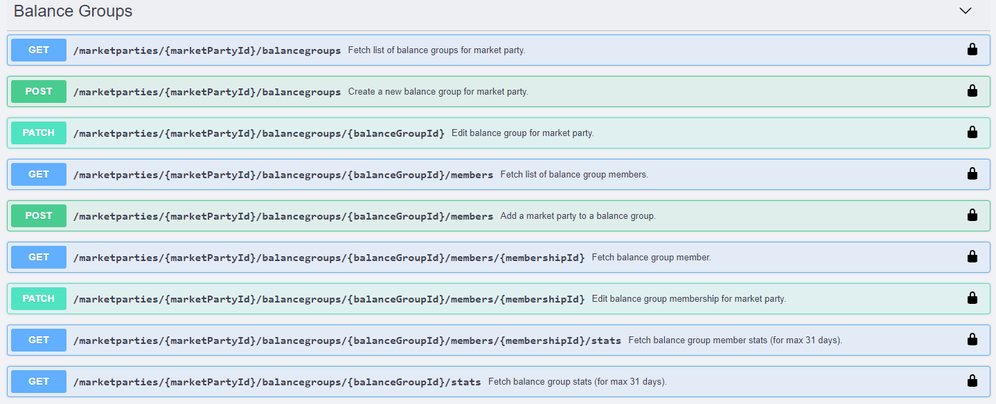
Using API endpoint for balance responsible shipper or trader
- Market Party ID
- Balance Group ID
- Member ID in balance Group

Balance information – shipper or trader

Using API endpoint
- Market Party ID
- Balance Group ID
- Member ID in balance Group

Forecast of System Imbalance in yellow zone

If the forecast imbalance for the Gas Day is in the Yellow Zone, the TSO may trade on the Gas Exchange. The TSO may trade, partly or entirely, the quantities of gas corresponding to the difference between the most recent value of the forecast imbalance and the value that defines the border between the Green Zone and the Yellow Zone in relation to within-day products. The difference shall be rounded up to the smallest tradeable unit on the Gas Exchange.
As long as the forecast imbalance is in the Yellow Zone, the TSO may trade on the Gas Exchange every hour from 11:00 EE(S)T until the start of the last delivery hour of the Gas Day. The TSO shall publish in the Portal information on the highest purchase price and lowest sell price of the trades of the TSO at the Gas Exchange.

